Design document – Case study 1

Student: Marko Šestanović
PCN number: 558991

Table of Contents
1. Project overview 3
2. Requirements 4
3. Network topology 5
4. Execution plan 6
5. Choice justification 7

Project overview
The goal of this project is to create an environment which will be hosted on one of the cloud providers. The environment is supposed to be used for a short period during the peak hours for tickets sales of an event. The environment should function normally during those peak hours, but keeping the costs low should be in mind during development. The environment will consist of 2 web servers and a single database. Apart from that, the environment should have all the appropriate security, maintenance, and scalability functionalities.

Requirements
Functional requirements:
- The environment will follow hub-spoke model
- Full environment hosted on the cloud
- Implement appropriate and up to date security and monitoring measurements
- Implement automated solutions for different workflows
Technical requirements:
- DNS server allowing querying of the resources inside the environment
- Automated CI/CD pipelines for building testing and deploying updates
- Integrated DevOps platform to manage the source code and pipelines
- VPN access to the internal network

Network topology
The network will consist of the following:
- ALB will be the only service exposed to the internet
- Two web server instances in different availability zones
- The database will be in the private VPC
- VPN tunnel for access to the private VPC
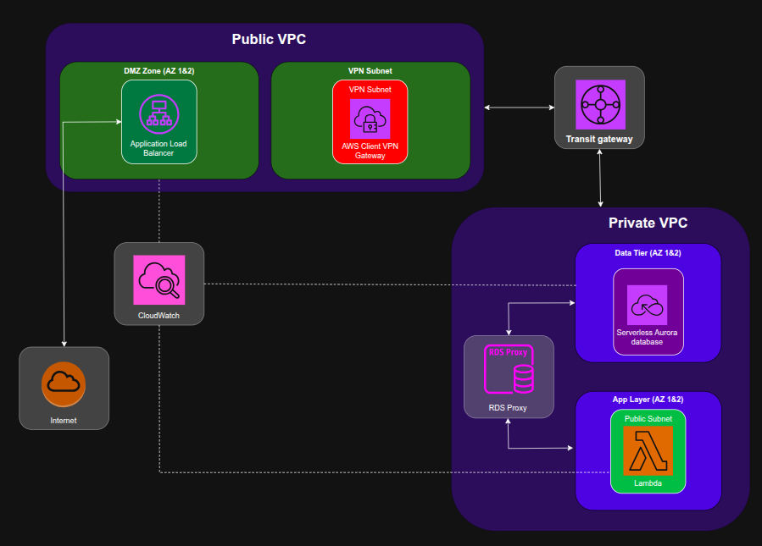The picture above shows the network diagram for the environment.

Execution plan
Phase 1: Technical design
- Provide the Design Document
- Justify the technology choices
- Initial Project plan
- DevOps project setup
Phase 2: Infrastructure implementation
- Deploy cloud network
- IaC scripts for infrastructure
- Scalable front-end
- Deployed PaaS database
Phase 3: Monitoring Integration
- Deploy basic monitoring
- Implement basic alerts
- Document monitoring setup
Phase 4: Testing, Resilience and Documentation
- Test monitoring implementation
- Test up and downscaling capabilities
- Test “design-for-failure"
- Make sure everything is finalized and documented
- Submit project documentation
- Prepare and deliver a presentation

Choice justification
Provider – I decided to use Aws as my cloud provider because I don’t have any prior experience using it and it is used in the industry. Since I used Azure in the previous semester, Aws seemed like the best option for this semester.
Web server – For the web server, I decided to go for the serverless option. Because the main objective of this case study was scalability, serverless seemed like the best option. So, for my web server, I used Lambda.
Database – When choosing the database, there are two options, RDS Aurora or DynamoDB. DynamoDB is a serverless database, and this would immediately make it the best option. It can easily scale and handle millions of requests. But one of the requirements is to have a relational database, which DynamoDB isn’t since it is a NoSQL database. Hence, I decided to use Aurora RDS which is based on MySQL or PostgreSQL. The Aurora database is serverless, but you are still required to specify the minimum amount of CPU and RAM it should use.
Backend communication – Since my environment consists of a private and public VPC, both my web server and database are in the same private VPC. This means that I could have a direct communication from the web server to the database. The issue with that design is that Lambda is a serverless web server, hence it would make too many requests to the database, and it would crash. That’s why I needed to implement an RDS proxy which would handle the requests and make sure the database can handle them.
Monitoring – As my monitoring solution, I decided to use CloudWatch + Grafana. This is because CloudWatch is incorporated into every service by default and all I need to do is deploy Grafana and I would have my monitoring setup.

